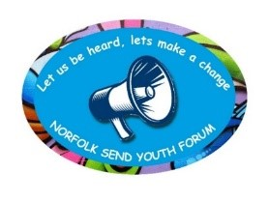
Norfolk SEND Youth Forum

Saturday 11th July 2026 - 10am – 2pm

Meeting Minutes
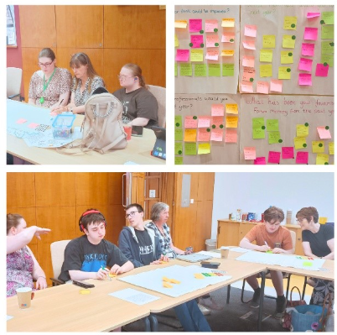
Attendees:
Sally Bailey (Norfolk SENDIASS)
Belinda Coxall (Norfolk SENDIASS)
Emma Henry (Norfolk SENDIASS)
Dawn Jones (Inclusion & SEND, NCC)
Charlotte
Lily
Alec
Isacc
Sarah
Reece

Apologies:
Bridget Robinson (Norfolk SENDIASS)
Callum
Katrina
Charlie
Gabriel

Welcome and updates
SB, EH, BC and DJ welcomed everyone to the meeting. Katherine brought some delicious brownies to share with everyone – Thank you!
Our updates from everyone in the room were wonderful:
Charlotte – Helped her friend get ready and take photos for prom.
Sarah – Is excited for her friend to welcome a new baby.
Isaac – Has gladly accepted an offer to study at higher education level at Norwich University of the Arts.
Alec – Has recently passed his BTEC course and is going on to study photography. Alec also kindly showed us some of his photos he has taken of Norfolk wildlife and the demolition at Anglia Square.
Reece – Enjoyed being on the Judging Panel for the Flourish Awards and said the day was very interesting – he is also looking forward to a new chapter at College in September.
Lily – Has secured an interview for an expert by experience role that we recently shared with the group and is also looking forward to starting work experience and summer school.

Questions and feedback
- What has been your favourite Youth Forum memory from the past year?
- Free pizza
- Bowling / Golf
- Going to the Flourish Awards
- Giving my feedback for the Flourish Awards
- People being nice to me
- People listening to what I have to say
- I really enjoy all aspects of The Youth Forum, it’s nice seeing everyone
- I enjoyed the talk about help with employment
- Going to the Job Interviews (Engagement and Advice Officers)
- Going to Hertfordshire!
- Meeting the boys for the first time
- Laughing with everybody
- The Flourish Awards (we better win)
- Ryan the Educational Psychologist (The GOAT)
- Meeting up with everyone
- Seeing my friends achieve their goals
- Getting to be on the interview panel
- All the smiles and laughs we have shared together
- Getting good feedback from the professionals we’ve helped!

- Was there anything about the Youth Forum that you didn’t enjoy, or you think could be improved?
- SENDFEST (we used to be involved but weren’t this year, no YF members managed to get tickets to go. What happened?)
- Different locations for meetups, not always Norwich
- Arrange meetups earlier in advance
- Young People recruitment form needs updating as currently poses a barrier to new members
- Make the professional consultation pre-meet with Emma/Sally/Bridget compulsory
- Presentations professionals give can be hard to understand at times like big words or confusing sentences. Also long.
- Giving updates to things that are going on that others might want to know about e.g. new rules for young people or if a new place opens up nearby that might interest us.
- Hear more from the young person than from the professional
- Professionals to credit us such as our logo / email and a short detail about us.
- Make sure the professionals come back with feedback
- Nothing I didn't enjoy
- Make sure everyone has a chance to say something
- The professionals not listening to our suggestions, wasting time for us which could have been spent for someone who would listen and help. Also puts us off giving advice in the future if this keeps happening
- Professionals are not crediting us for out inputs
- People who don't come back or respond e.g. the SEND survey people
- Professionals to explain themselves more
- Make sure professionals are listening to us
- Sometimes I feel shy in the meetings. Maybe being asked direct questions would be helpful.
- Good that you can send chat messages during the meeting
- The time goes too quickly
- Everyone can get involved in their own way
- I can’t think of anything I don’t like or needs improving - it’s an amazing group!! ☺️

- What meetups would you like to do next year?
- County Hall
- Pizza Express
- Bowling
- Watching a movie and ordering takeaway
- Bella Italia
- Horse Riding
- Going to watch a show and have a meal
- Craft activities
- Cooking Activity
- Dancing
- Frisbee Golf at Bradwell
- Bowling
- Wildlife Park
- Cooking workshop
- Rage room
- Escape room
- Puppet workshop at the puppet theatre
- Boating / river ride
- Gravity / trampolining and climbing wall
- Musical instrument workshop
- Golf
- Cooking workshop (maybe the lady who did it with us last time?)
- Art design workshop
- Retro arcade (gaming)
- More bowling and gold
- Craft workshop
- Gaming cafe
- Go-karting at Cromer
- Tennis maybe?
- Roller skating
- Bowling

- What kinds of professionals would you like to speak to next year?
- RYAN (come back)
- Understanding AI and how to be safe with it
- Someone talking about freelance and how to become an independent business / freelancer (another member agreed with this)
- Talk about Technology
- Learn more about masking / unmasking
- Making changes in schools
- How to live on your own and feel confident doing so post-18
- People to help with volunteering and working
- Dragons (NANSA)
- Someone talk about how young people can become independent and confident
- Professionals to explain why nothing is available after college = no support !
- Business + waitress
- Access College
- People offering hobbies and how to get involved
- Job opportunities
- Sport people how to get healthier
- City college – purple phoenix
- Someone from family voice / SENDFEST
- Health support including wellbeing
- It would be interesting to speak to some people involved maybe in PIP (I know Lily and I have had things we’ve wanted to do to speak up about the PIP system!) potentially any professionals in the education setting, or mental health settings - I feel like those are the areas where things in the system need to change and I think a lot of us would have some good input! Not sure of specifics but that was just general ideas.

Easy Read Document feedback
Feedback about the document was as follows:
- Front cover
- Update photos, seem dated
- Front page title – title could be bigger, stands out more
- Add more colour to front page, to draw more people's attention
- Not sure if “children and young people's edition” is necessary for title?
- Easy-read image is off-centre, could be positioned more in the middle
- More (SENDIASS) logo in replacement of the subtitle
- Inside content
- Different colour background for each different heading, idea of having a colour palette and these colours on the SENDIASS logo (green, pink and blue)
- Maybe avoid using loads of people in the images
- All the pages and tables look the same, maybe make some different like with bullet points, for example pages with shorter sentences could have bullet points instead
- Use a different word to ‘secret’. This seems inappropriate
- Bridget's photo needs to be less blurry
- This was made with help from our SEND Youth Forum and logo on the back page / bottom ?
- Too much writing in ‘what EHCP stands for’ box on page 4
- I like the how to get help from Norfolk SENDIASS page
- I like the photos of Emma, Sally and Bridget
- I like to see Gabriel, Lily and Reece, I would like to be in it too (Sarah). I would like to be included with a quote (Charlotte)
- I like the pictures
- Too much writing in the second box on the ‘Norfolk SEND Youth Forum page’, page 11
- Nice and clear
Alec, Isaac and Charlotte also kindly gave us quotes to include in the document and other places, alongside those from Gabriel, Lily and Reece that were already in place.
- “Youth Forum has helped with my confidence” - Charlotte
- “Your opinions help the future of Young People” -Isaac
- “When I know something, I can talk about my experiences at SENIDASS” - Alec
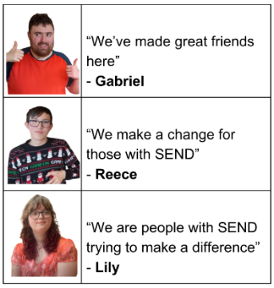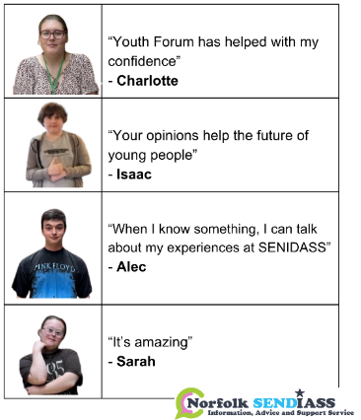
Date of Next Meeting

The next meeting will be on the 23rd of September.
Thank you for all your contributions!

