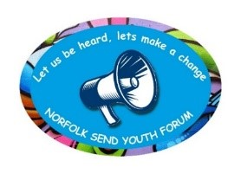
Norfolk SEND Youth Forum

Wednesday 14th January 2026 - 6:30pm – 7:30pm

Meeting Minutes
Attendees:
Bridget Robinson (Norfolk SENDIASS)
Belinda Coxall (Norfolk SENDIASS)
Dawn Jones (Inclusion & SEND, NCC)
Alec
Katrina
Charlotte
Reece
Isaac
Lily

Apologies:
Charlie
Callum

Welcome and Introductions – Bridget welcomed everyone to the meeting.

Professional Consultation: Adapt-Ed – Research Project from the University of Hertfordshire
Rebecca Connell and Lauren Denyer attended the meeting: -
- We visited you last year to find out what you think about school food.
- You told us that one bad experience with school food can have a big impact and choosing what you eat and where you eat it is important.
- You also gave us feedback on a logo and ideas about who else we could talk to.
- We really enjoyed talking to you and you helped us make decisions about the project.
- We have come back to tell you how what you told us helped our project.
- We also want to know if you have questions about food and eating that we could help answer
SENDfest
Adapt-Ed attended SENDfest in July 2025 as suggested by the Youth Forum.

A ‘bin’ was put near their stand with the question ‘What’s rubbish about food and eating at school?’ and they collected the answers.

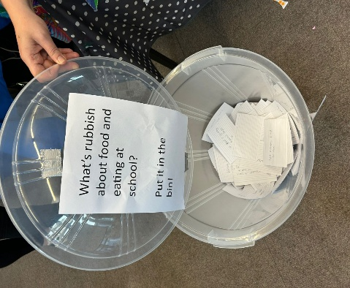

There was a logo competition voted for by putting a dot next to their favourite logo. The Youth Forum thought the winning logo with the colourful circles was a good choice.
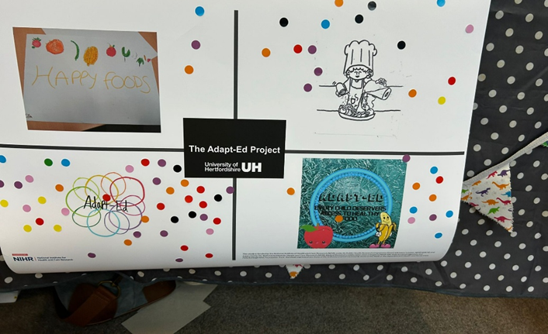

Rebecca really enjoyed SENDfest and would like to come again if there is another one in the future.

Podcast

The Adapt-Ed project team and Broxbourne SEND Youth Council produced a podcast and a poster. Here is podcast link – School Food for SEND podcast (2025) for the Youth Forum to listen to.



Research

Lauren shared a video to explain what a researcher is:-

- Would you like to get involved in doing research?
- If you could do research about food and SEND, what questions would you ask?
Questions Youth Forum would ask about Food and SEND
Some of the group said they would like to be involved in doing search and if so these were the questions they would ask: -
- What textures/smells/tastes make you anxious?
And which one’s comfort you?
What helps when you are anxious?
What is your go to safe meal/snacks?
What can other people do to help if you are anxious about eating?
What makes you anxious about food?
- I think if I could research about it, I would research if different levels of either autism or ADHD have similarities in their safe foods or foods they like, to get a better understanding of what foods could be the best to choose so it can cover all different levels of people with SEND
- Helpful in hospitals as a lot of people, not being too experienced in SEND but can look at the common safe foods so they know the patient will like what they eat!
- Especially for allergies!
- Handing out menus in hospital so patients can choose what they want to eat and what they like.
- That’s exactly what school food tastes like as I have the same when I had my surgery a few years back, trying to eat it, it definitely tastes like school food. I’m allergic to dairy and I am so anxious too about finding food.
- It's also important to research what chemicals and e numbers are in different foods and what reactions could people get from them.
- I think a lot of schools should have a plate with walls to separate each food so people can feel comfortable ordering food in school knowing it will be plated properly!

The group shared their experiences at their colleges: -
- My college doesn’t have any cafe as it’s very small, but the college I did go to that had a cafe (city college) was very varied in both hot and cold, so I was always able to find something to eat, even if it wasn’t a full meal.
- In my college before around March 2025 whenever I got a break during College I would usually walk up to Greggs. However now I have a lunch bag now as that Greggs has closed.
Rebecca and Lauren said they would note the group’s ideas and comments and consider these if there was funding in the future for any projects.
Rebecca and Lauren thanked the group for all their input and if the group had any other comments/ideas after the meeting to forward them through Bridget/Belinda.
Feedback From Consultation with Claire Jones Re Focus Group for Local Offer Website
Claire Jones came to the group last year to ask if any Youth Forum members were interested in helping with a project to develop and improve the Local Offer website. Bridget attended a meeting recently with Claire to give the group’s feedback about dates, commitment to attending all four sessions and what was involved.
Claire Jones has arranged a session on Friday 20th February (half term) at County Hall for those interested to attend to see what it’s about and whether they want to take part.
- Claire to send details to Bridget who will pass information to the group
- Paul Webb will be there to help.
- Sally and Emma from SENDIASS will be there to help.
- £20 gift voucher for attending
- Lunch provided – can order in advance
- Transport provided - taxi paid for if needed
- Parent/carer can attend as well
Bridget asked if anyone would like to attend and responses as follows:-
- Because of college I might want that week to rest, but I’d still like to be sent the information just so I can see because you never know!
- It all depends all on the days for me as the reason why i couldn’t do it last time was due to what days they were since they overlap college days
- Would they think about doing it online at all? Maybe just a zoom meeting and sharing the information? They may do it if they get more people through it
Bridget to ask Claire if the sessions can be done virtually for those who would like to be involved but cannot do face-to-face.
Practice Week - 18th – 22nd May 2026
Childrens Services Practice Week will take place on 18th - 22nd May 2026 and the theme is “Individual”.
Bridget asked if anyone would like to take part as some members had in the past and it would be good to get their experiences heard.
Bridget asked the group to think about what they would like to do i.e. presentation, art works, pre-recordings, poems etc.
To be discussed in more detail at the next meeting.
Any Other Business - There was no other business.
Date of Next Meeting
The next meeting via TEAMS on Wednesday 11th February 2026.
Thank you for all your contributions!

