Norfolk SEND Youth Forum
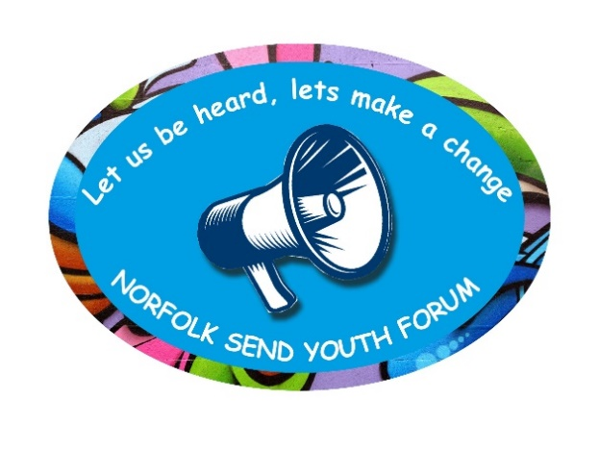
Minutes to Meeting: 19th January 2022, 6.30 – 7.30pm

Attendees
Katrina
Lewis
Charlotte
Bethan
Gabriel
Isaac
Dawn Jones (SEND Advisor – Inclusion & SEND Team, NCC)
Bridget Robinson (CYP Supporter – Norfolk SENDIASS)
Belinda Coxall (BSO – Norfolk SENDIASS)
Steph Askew (Senior Adviser for SEND, SEND Strategic Improvement and Early Effectiveness, NCC)
Mark Gower (Designated Clinical Officer (SEND), NHS Norfolk & Waveney Clinical Commissioning Group)

- Introductions- Everyone introduced themselves and welcomed Isaac to the group.

- Ice Breaker – Bridget asked members for any ideas/statements to encourage more young people to join the Forum.
Lewis suggested the words “Fun and exciting” and put forward the idea of a Bowling party for the group.
Bethan: “ A group of people like you, that feel like you”.
Gabriel: “It’s a great social group and the chance to share opinions and experiences. We are all unique and all brilliant” (Nina & Neurons)
Katrina: “If you are looking for a safe place with a community of incredible understanding and chats for people with SEND this is the place. It is the most accepting group and a breath of fresh air and the meetings have helped more than I could explain, it is awesome.”
- Professional consultation – Mark Gower

Mark told the group that he is a trained nurse, and in current role in the NHS he was seeking their feedback about annual health checks available to young people aged 14 years and over who have a Learning Disability.

Information from justonenorfolk website:

14+ Yearly Health Checks are for anyone aged 14 or over with a learning disability who are on the GP practice learning disability register. Once on the register at your GP practice, you should be invited to come for an annual health check.
You can ask to put yourself on the register if you think they have a learning disability. You can also get someone else to do this for you. The learning disability register is different from the register of social care needs managed by local councils. You can check with your healthcare centre if you are on the register.
Some healthcare centres may not offer yearly health checks. If not, you can ask them if they could provide one. If they say no, ask your local community learning disability team for advice. They should be able to help you access an annual health check.

Who Can Help?
For more information on the 14+ health check you can visit Norfolk County Council's information page.
You can also contact the Healthy Child Programme by calling Just One Number on 0300 300 0123 or texting Parentline on 07520 631590. Our opening hours are 8am-6pm Monday-Friday (excluding bank holidays) and 9am-1pm on Saturdays.
If you are 11-19 you can text ChatHealth on 07480 635060 for confidential advice from one of our team.

Mark shared an animated video, which promotes these Health checks. Click on the link (in blue) to watch again.

https://www.justonenorfolk.nhs.uk/childhood-development-additional-needs/additional-needs/14plus-health-check

Mark had some questions for the group to consider:
Did you know about these health checks?

Feedback from group:

“ I didn’t know about these health checks. What age do they go up to?”

“I do not have a Learning Disability and thus do not have these checks. I didn’t know this was a thing but its good. I found this video was informative and explained what it was clearly-also good that it mentions that its your choice for certain things like blood tests, as someone with a big fear of needles its good to have control over the situation and be able to do it at your own pace.”

“I have never heard anything about the check-ups, how do you get notified? I have been unwell for years and I have never had this and needed it. If anything, the doctors haven’t been too good on keeping up checks and listening to me.”

If the doctor knows you have a Learning Disability, why hasn’t it been offered?

Mark advised members that they should contact their GP, if they are over 14 years and have a LD.

What was it like?

Feedback from group:

“My health check was OK.”

“Our surgery rings and we make the appointment”

“We get a letter and a form.”

Ideas for how to promote these Health checks when young people reach 14 years e.g., birthday card

A birthday card or letter and making it sound fun and good for them.

It needs to sound fun and positive, especially for a 14-year-old.

A Happy Birthday text…….” Don’t forget you can get an annual health check.”

Breaking down what it is about, where you have to go, and who would be doing it.

Just a thought…especially if it gets rolled out wider – saying “If you are a man/woman” might be potentially excluding language to people who identify as non-binary.”

“My autistic self says absolutely not a phone call. The birthday card sounds kind of fun, makes it quite positive”

- Steph Askew: Steph reported back to the group, and shared a PowerPoint presentation , (please see in separate attachment), to share the results of her recent questionnaire. The group provided additional feedback.

Feedback:

“I would say hello, be kind.”

“So much of this is super super important, especially as in mainstream schools’ disability is often seen among children as another – good relationships with other students and also good relationships with teachers can really help, the latter particularly helped me during my high school years.”

“Just that young people are offered the support they are entitled to and steps to make sure they feel supported.”

“Remembering I am (their name) and not just autistic.”

“That is absolutely spot on. While ASD can for some be a huge part of a person’s identity (I fall into that category) there is still more to them.”

“To be patient and ready to listen and make time for people.”

“I definitely break that stereotype; I am a big fangirl of too many K-pop groups to mention.”

Dawn asked: How do we make time to listen?

“ In through the back door!”

AOB: (Any other business)
The meeting was closed, after Charlotte shared a picture of her working in the Children’s ward of a hospital, in her uniform. Well done Charlotte.

Everyone was thanked for their attendance and contributions.

Date & Time of next Meeting: Wednesday 23rd February, 6.30 – 7.30pm.

