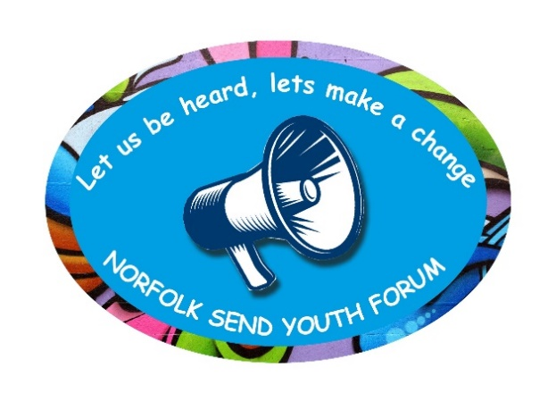

**Norfolk SEND Youth Forum**

**Wednesday 15th September 2021 6:30 pm – 7:30pm**

**Meeting 8: Minutes (What has been discussed.)**

**Attendees:**

Charlotte

Gabriel

Katrina

Bethan

Maxine (Senior Advisor SEND, Norfolk County Council)

Dawn (SEND advisor, Inclusion and Opportunity Service)

Belinda (Norfolk SEND Partnership – SENDIASS)

Rachel (Norfolk Museum Service)

Claire (Norfolk SEND Local Offer)

**1. Welcome/new members**

Apologies received from Bridget and Lewis.

Claire introduced herself and explained to the group what the Norfolk Local Offer website was. Claire will be working with Maxine on developing a Young Person’s page on the Local Offer website and will be attending future meetings to work with the group on this.

**2. Kick the Dust Project (Norfolk Museums Service) – update from Rachel**

Rachel had to leave the meeting early so this item was moved to the start of the meeting.

Rachel said that the Kick the Dust Project was going to publish a booklet on the exhibition and the credits were being put together.

Rachel asked everyone if they wanted their own name or the group name published in the accompanying booklet.

Katrina, Gabriel and Charlotte were happy to have their names published and Belinda would check with the other members and let Rachel know.

Rachel said that for the Disability History Month in November an A-Z was being produced and everyone was happy to include the Youth Forum as the ‘Y’ in the booklet.

Gabriel suggested using the Youth Forum logo and this was agreed.

Rachel left the meeting.

**3. Ice Breaker Game**

The group took part in an ice breaker game by Wordwall and the questions were about everyone’s summer experiences. The group had done lots of things over the summer and they had gained new skills and experiences. Gabriel asked for access to Wordwall and the link is below:-

[Wordwall | Create better lessons quicker](https://wordwall.net/)

**4. Review minutes of last Meeting** - No minutes as last meeting was a Pizza night.

**5. Understanding our Rights – CDC quiz -** This item to be added to the agenda for the October meeting.

**6. Norfolk Area SEND Strategy (Maxine and Claire)**

Maxine said how pleased she was to be back at the meeting and seeing everyone again.

Maxine thanked Belinda for sending out the rewards to the Youth Forum members.

Maxine talked about the plan to develop a Young Person’s page on the SEND Local Offer website and said the group’s ideas from the last meeting on ‘What was Important to You’ would be included on the page. The page would be created by the group and it would have their ideas and what they wanted on it.

Claire showed the group the software which was called Padlet and how it worked and how to add and change things. Maxine discussed with everyone what they wanted on the page and suggestions included poems, artwork, recipes, links to websites like Titan, interests and hobbies etc.

A link to Padlet and instructions would be emailed to everyone. Maxine said the group could add the information on Padlet themselves or email their ideas to Belinda who will pass them on to Maxine and Claire.

The Young Person’s page will be worked on with Maxine and Claire at future meetings.

**7. Any other business (AOB)­**

Wellbeing/Mental Health Support

The group agreed they would be interested in someone doing a talk on wellbeing at one of the meetings. Dawn will arrange this and ask the group at the next meeting what questions they would like the session to cover.

Mental Health Support

The group agreed they would be interested in a representative from MAP who are part of CAMHS to come and talk about mental health issues raised in previous meetings. Dawn will arrange this.

Healthwatch **-**  [Healthwatch Norfolk - Home - Join the conversation](https://healthwatchnorfolk.co.uk/)

The group agreed they would be interested in Healthwatch Norfolk coming to a future meeting so the group’s voice can be heard on improving health and care services. Dawn will arrange this.

Proposed KIDS sessions – (extra session Weds 24th and Weds 1st December).

Dawn reminded the group about the two extra sessions by KIDS which had been arranged on-line on 24th November and face to face on 1st December. The group were interested in attending the sessions on-line only and not face to face. Dawn will contact KIDS and let them know.

SEN Employment Pathways Workshop

Karin Porter from SEN Employment Pathways asked if a representative from the group would be able to attend a workshop in the afternoon on Tuesday 5th October. The group were unable to attend as they were at school or college.

Maxine agreed to present the views of the group from information gathered from the group at previous meetings.

The group could also add their views and experiences on employment on the Young Person’s page on the Padlet.

Kick the Dust Project

Bethan gave a quick update on the project. The project was taking shape with help from the volunteers in Kings Lynn and the text for the booklet had been written. Bethan will share the booklet with the group at the next meeting. Bethan had now started university but she hoped to still attend the meetings. Dawn thanked Bethan for all the work she was doing.

**8. Next meeting - Date & Time of next meeting:**

13th October 2021 at 6.30 p.m. – 7.30 p.m.

**Thank you to everyone for your participation and contributions**

